(Abdominal Pain During Pregnancy: Causes, Warning Signs, and When to Seek Medical Help
(Meta Title: Abdominal Pain During Pregnancy: Causes, Symptoms & When to Worry
Meta Description: Learn about abdominal pain during pregnancy, including normal pregnancy discomforts, trimester-specific causes, warning signs, and when to seek urgent medical care.)

Abdominal Pain During Pregnancy: Causes, Warning Signs, and When to Seek Medical Help


Experiencing abdominal pain during pregnancy can be worrying. While many women experience some degree of abdominal discomfort as their body changes to support a growing baby, not all pain is harmless. Some causes are a normal part of pregnancy, whereas others may require prompt medical assessment to protect the health of both mother and baby.
Abdominal pain can occur at any stage of pregnancy. It may feel like mild stretching, cramping, sharp stabbing pain, persistent aching, or severe pain accompanied by other symptoms. Understanding the possible causes, recognising warning signs, and knowing when to seek medical attention can help you feel more confident and ensure that serious conditions are identified early.

Is Abdominal Pain Normal During Pregnancy?
Mild abdominal pain is relatively common during pregnancy and is often related to the normal physical and hormonal changes occurring in the body.
As pregnancy progresses, the uterus expands significantly, surrounding muscles and ligaments stretch, hormone levels increase, digestion slows, and the baby's movements become stronger. These normal changes can all contribute to occasional abdominal discomfort.
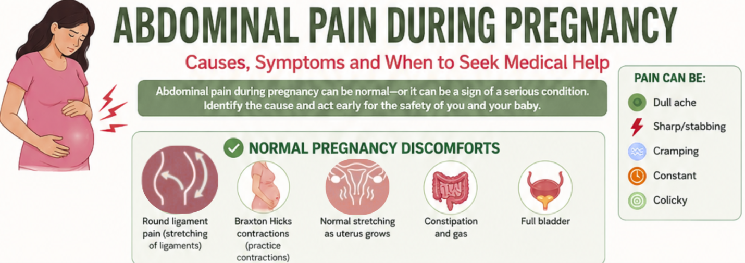
Normal pregnancy-related abdominal pain is usually:
- Mild to moderate
- Short-lasting
- Improves with rest or changing position
- Not associated with vaginal bleeding
- Not accompanied by fever or severe illness
However, severe, persistent, or worsening pain should always be assessed by a healthcare professional.

Common Causes of Abdominal Pain by Trimester
The possible causes vary depending on the stage of pregnancy.
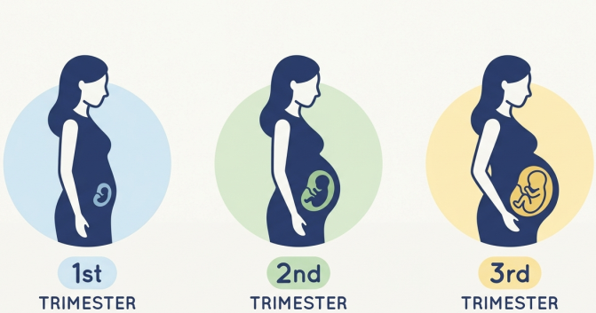

First Trimester (0–12 Weeks)
During early pregnancy, abdominal pain may be related to implantation, changes in the uterus, or complications affecting the pregnancy.
- Implantation and Early Uterine Changes
Some women experience mild cramping during early pregnancy as the fertilised egg implants into the uterine lining. This discomfort is usually mild, lasts only a short time, and may occur alongside light spotting.
As the uterus enlarges, women may notice occasional stretching sensations or mild pelvic discomfort.
- Miscarriage
Miscarriage is one of the most common complications of early pregnancy and frequently presents with lower abdominal cramps together with vaginal bleeding.
Symptoms may include:
- Cramping pain similar to menstrual pain
- Vaginal bleeding or spotting
- Passage of blood clots or pregnancy tissue
- Lower back pain
Any bleeding during pregnancy should be consulted with a healthcare professional.
- Ectopic Pregnancy
An ectopic pregnancy occurs when the fertilised egg implants outside the uterus, most commonly in the fallopian tube. It is a medical emergency because the pregnancy cannot develop normally and may cause life-threatening internal bleeding if the ectopic pregnancy ruptures.
Symptoms may include:
- Abdominal pain
- Vaginal bleeding
- Shoulder-tip pain
- Dizziness or fainting
- Collapse in severe cases
Anyone with these symptoms should seek emergency medical care immediately.

Ovarian Cysts
Some ovarian cysts, particularly corpus luteum cysts, develop naturally during early pregnancy and usually disappear without treatment.
Occasionally, ovarian cyst may:
- Become large
- Twist (ovarian torsion)
- Rupture
These complications can cause sudden severe pain and require urgent assessment.

Degeneration of Uterine Fibroids
Some women have uterine fibroids before pregnancy. During pregnancy, increased blood flow and hormonal changes may cause fibroids to enlarge. If a fibroid outgrows its blood supply, it may undergo red degeneration, causing significant pain.

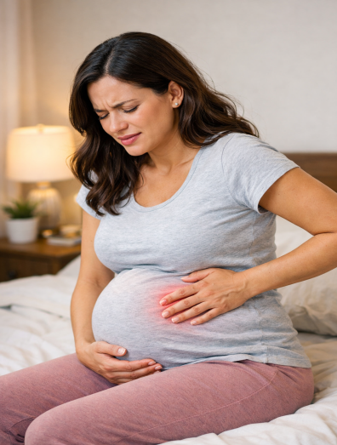

Second Trimester (13–27 Weeks)
Many causes of abdominal pain during the second trimester are related to the growing uterus, although pregnancy complications can also occur.

Round Ligament Pain
Round ligament pain is one of the most common causes of abdominal pain during the second trimester.
The round ligaments support the uterus. As the uterus enlarges, these ligaments stretch and tighten, causing sudden sharp pain, often on one side of the lower abdomen or groin.
The pain commonly occurs when:
- Standing up quickly
- Rolling over in bed
- Coughing
- Sneezing
- Exercising
Although uncomfortable, round ligament pain is harmless and usually lasts only a few seconds or minutes.

Constipation and Gas
Pregnancy hormones slow digestion, allowing food to remain in the intestines longer. Iron supplements, reduced physical activity, and the growing uterus pressing on the bowel may worsen constipation.
Constipation can cause:
- Cramping, Bloating
- Gas
- Lower abdominal discomfort
Drinking adequate fluids, eating a fibre-rich diet, and remaining physically active often improve symptoms.

Urinary Tract Infection (UTI)
Pregnant women are at increased risk of urinary tract infections because hormonal changes relax the urinary tract and make bacterial growth more likely.
Symptoms include:
- Lower abdominal discomfort
- Burning during urination
- Frequent urination
- Fever (if the infection reaches the kidneys)
- Back pain
UTIs should be treated promptly during pregnancy because untreated infections increase the risk of kidney infection and preterm birth.

Kidney Stones
Although less common, kidney stones can occur during pregnancy.
Typical symptoms include:
- Severe pain in the side or back
- Pain radiating toward the groin
- Blood in the urine
- Nausea and vomiting
Hospital assessment is usually required.

Third Trimester (28 Weeks Until Birth)
As pregnancy advances, abdominal pain becomes more common because of the baby's size and preparation for labour. Nevertheless, serious conditions become increasingly important to recognise.

Braxton Hicks Contractions
Braxton Hicks contractions are usually painless tightening often called "practice contractions." Sometimes they’re referred to as false labour pains.
These contractions:
- Occur irregularly
- Usually improve with rest or hydration
- Do not become progressively stronger
- Do not cause cervical dilation
Many women notice them after exercise, dehydration, or increased physical activity.

Preterm Labour
Regular abdominal tightening before 37 weeks may indicate preterm labour.
Symptoms include:
- Regular contractions
- Pelvic pressure
- Lower back pain
- Vaginal discharge or fluid leakage
- Cervical changes
Prompt medical consultation and assessment improves outcomes for both mother and baby.

Placental Abruption
Placental abruption occurs when the placenta separates from the wall of the uterus before delivery.
This is a medical emergency.
Symptoms include:
- Sudden severe abdominal pain
- Vaginal bleeding (although bleeding may sometimes be concealed)
- A hard or tender uterus
- Reduced fetal movements
- Frequent or continuous contractions
Immediate hospital care is essential.
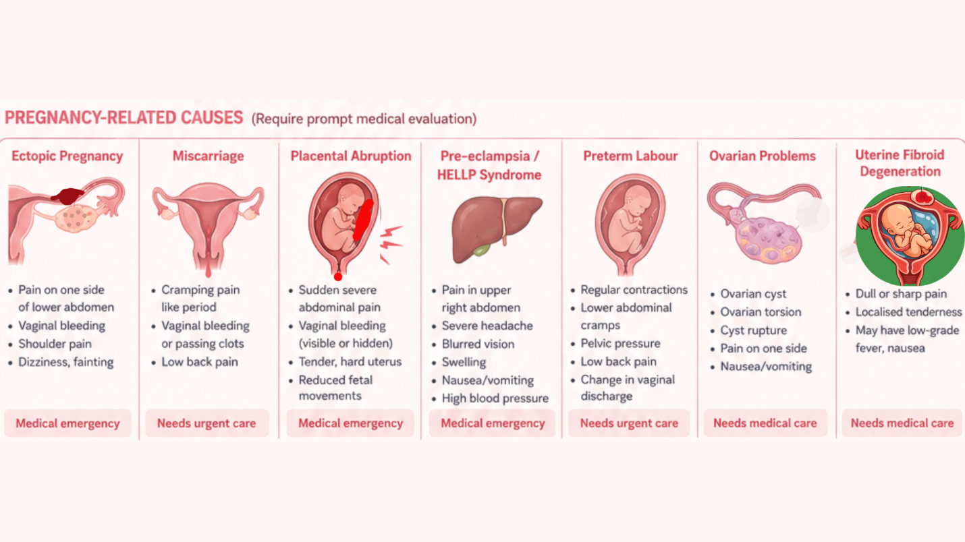

Preeclampsia and HELLP Syndrome
Severe pain in the upper abdomen, particularly beneath the right ribs, may indicate preeclampsia or HELLP syndrome.
Other symptoms include:
- Severe headache
- Visual disturbances
- Swelling of the face or hands
- High blood pressure
- Nausea or vomiting in late pregnancy
These conditions require urgent assessment because they can become life-threatening for both mother and baby.
Other non Obstetrical Causes of Abdominal Pain During Pregnancy
Not every episode of abdominal pain is directly related to pregnancy. Women can also develop common medical conditions during pregnancy, including:
- Appendicitis
- Gallstones
- Gastroenteritis
- Pancreatitis
- Inflammatory bowel disease
- Kidney urinary disorders
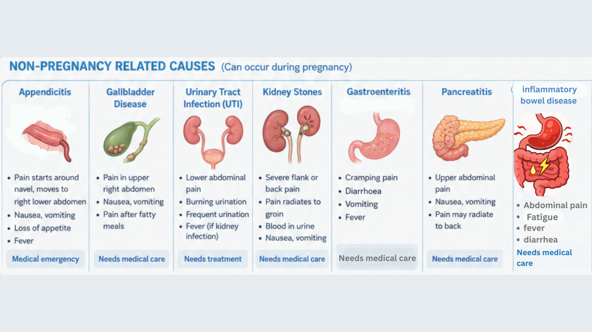
Diagnosing these conditions can be more challenging during pregnancy because the growing uterus changes the position of abdominal organs. Healthcare professionals may recommend blood tests, urine tests, or ultrasound to determine the cause safely.

Warning Signs That Should Never Be Ignored
Seek urgent medical attention immediately if abdominal pain is accompanied by:
- Severe or persistent pain
- Heavy vaginal bleeding
- Shoulder-tip pain
- Dizziness, fainting, or collapse
- Fever or chills
- Persistent vomiting
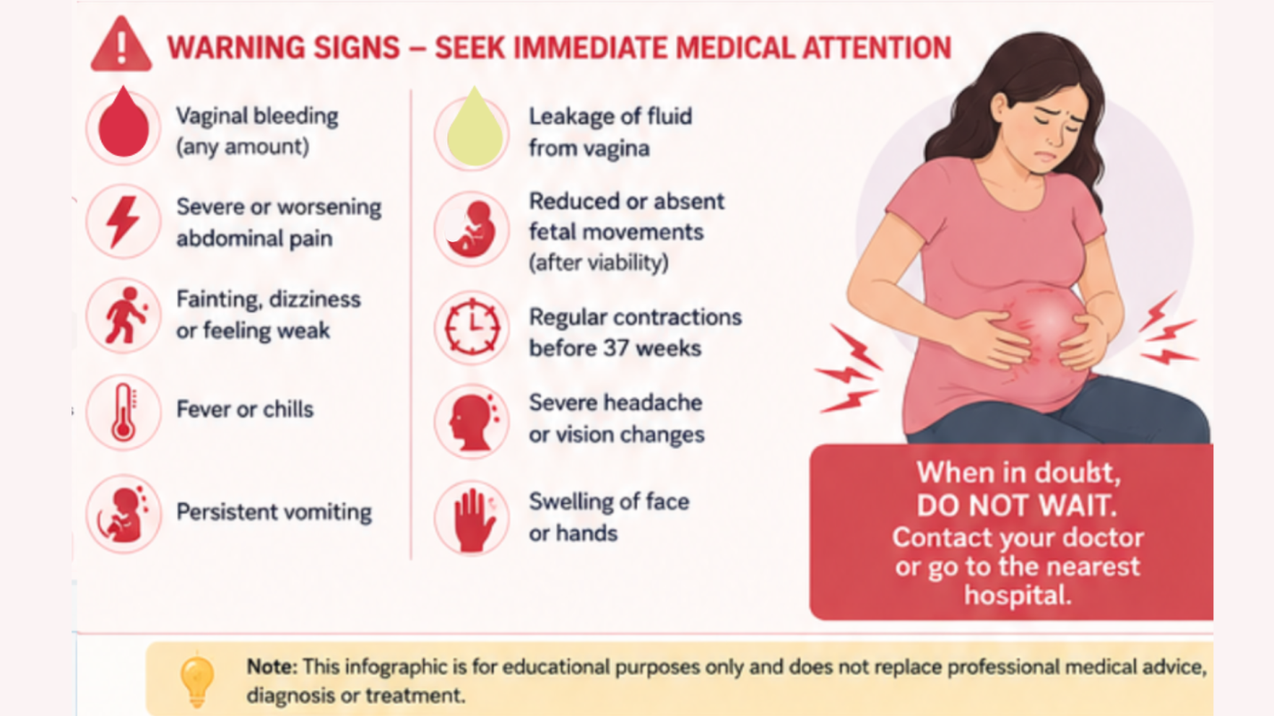
- Painful urination with fever
- Leakage of fluid from the vagina
- Regular contractions before 37 weeks
- Reduced or absent fetal movements after fetal movements have been established
- Severe upper abdominal pain with headache or visual changes
These symptoms may indicate a pregnancy emergency that requires immediate medical evaluation.

How Is Abdominal Pain During Pregnancy Diagnosed?
Diagnosing abdominal pain during pregnancy begins with a careful assessment by your healthcare provider.
Your healthcare provider would ask about:
- When the pain started
- The exact location of the pain
- Whether the pain is sharp, dull, cramping, or constant
- Pain severity and duration
- Associated symptoms such as vaginal bleeding, fever, nausea, vomiting, urinary symptoms, contractions, or reduced fetal movements
- Your pregnancy history and any previous pregnancy complications
A physical examination may include checking your abdomen, measuring your blood pressure, assessing your temperature, and listening to your baby's heartbeat if appropriate for your stage of pregnancy.
Depending on your symptoms, additional investigations may include:

Urine Tests
A urine sample can help diagnose:
- Urinary tract infection
- Kidney infection
- Kidney stones
- Dehydration

Blood Tests
Blood tests may be performed to look for:
- Infection
- Anaemia
- Liver function abnormalities
- Kidney function
- Pregnancy hormone (hCG) levels in early pregnancy
- Blood group and Rh status if bleeding occurs

Ultrasound Scan
Ultrasound is the preferred imaging test during pregnancy because it does not use radiation.
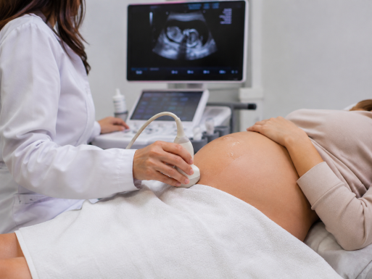
It may help identify:
- A normal intrauterine pregnancy, Fetal wellbeing
- Ectopic pregnancy
- Miscarriage
- Ovarian cysts, fibroids
- Placental abnormalities
- Any problem in abdominal organs like Appendix, gallbladder, liver, kidney, bladder

Fetal Assessment
Later in pregnancy, your baby's wellbeing may be assessed using:
- Fetal heart rate monitoring (cardiotocography or CTG)
- Ultrasound assessment of fetal growth and wellbeing
- Assessment of amniotic fluid volume
- Doppler studies when indicated
Occasionally, if ultrasound is inconclusive, magnetic resonance imaging (MRI) may be recommended because it provides excellent images without exposing the fetus to radiation.

Treatment of Abdominal Pain During Pregnancy
Treatment depends entirely on the underlying cause. There is no single treatment suitable for all types of abdominal pain.

Normal Pregnancy Discomforts
For round ligament pain, Braxton Hicks contractions, or stretching discomfort, treatment usually includes:
- Rest
- Gentle position changes
- Adequate hydration
- Light stretching exercises
- Wearing supportive maternity clothing if needed
These symptoms often improve as the body adapts to pregnancy.

Constipation
Constipation can often be managed by:
- Increasing dietary fibre through fruits, vegetables, legumes, and whole grains
- Drinking plenty of water
- Regular gentle exercise such as walking
- Taking pregnancy-safe laxatives if recommended by your healthcare provider

Urinary Tract Infection
UTIs require prompt treatment with antibiotics that are considered safe during pregnancy.

Kidney Stones
Management depends on the size and location of the stone but may include:
- Pain relief
- Intravenous fluids
- Hospital observation
- Urological intervention if necessary

Pregnancy Complications
Conditions such as ectopic pregnancy, placental abruption, severe preeclampsia, HELLP syndrome, or appendicitis require urgent hospital care. Treatment may involve medication, surgery, close monitoring, or early delivery depending on the diagnosis and stage of pregnancy.

Safe Home Care Measures
If your healthcare provider has confirmed that your abdominal pain is not caused by a serious condition, the following measures may help relieve discomfort:
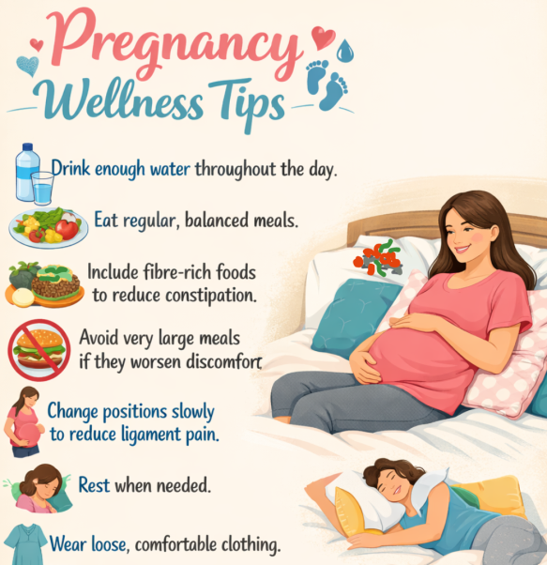
- Drink enough water throughout the day.
- Eat regular, balanced meals.
- Include fibre-rich foods to reduce constipation.
- Avoid very large meals if they worsen discomfort.
- Change positions slowly to reduce ligament pain.
- Rest when needed.
- Wear loose, comfortable clothing.
- Perform gentle pregnancy-approved exercises.
- Use pillows to support your abdomen and back during sleep.
- Empty your bladder regularly.

When Should You Seek Emergency Medical Care?
Go to your nearest emergency department or contact your maternity unit immediately if you experience:
- Severe or worsening abdominal pain
- Heavy vaginal bleeding
- Shoulder-tip pain
- Fainting or feeling as though you may faint
- Fever with abdominal pain
- Persistent vomiting preventing fluid intake
- Leakage of fluid from the vagina
- Painful regular contractions before 37 weeks
- Reduced or absent fetal movements after they have been established
- Severe headache with upper abdominal pain or visual disturbances
- Difficulty breathing or chest pain
Prompt assessment can help diagnose serious conditions early and improve outcomes for both mother and baby.

Summary:
- Mild abdominal discomfort is common during pregnancy and is often related to normal physical changes.
- The causes of abdominal pain vary depending on the stage of pregnancy.
- Serious conditions such as ectopic pregnancy, placental abruption, preterm labour, appendicitis, and preeclampsia require urgent medical attention.
- Persistent, severe, or worsening pain should never be ignored.
- Early assessment and appropriate treatment help protect both mother and baby.
- If you are unsure whether your symptoms are normal, contact your healthcare provider or maternity unit promptly.

Frequently Asked Questions (FAQ):

Is mild cramping normal during pregnancy?
Mild cramping is common, particularly during early pregnancy and as the uterus grows. However, severe pain, persistent pain, or pain associated with bleeding should always be assessed by a healthcare professional.

Can constipation cause severe abdominal pain?
Constipation can cause significant cramping, bloating, and discomfort during pregnancy. However, severe or persistent pain should not automatically be attributed to constipation without medical assessment.

Is one-sided abdominal pain always an ectopic pregnancy?
No. One-sided pain may also occur due to other reasons such as round ligament pain, ovarian cysts, appendix or other conditions. However, severe one-sided pain in early pregnancy—especially when accompanied by vaginal bleeding, shoulder-tip pain, dizziness, or fainting—requires immediate medical evaluation to exclude an ectopic pregnancy.

Can Braxton Hicks contractions be painful?
Braxton Hicks contractions may feel uncomfortable, but they are usually irregular, do not become progressively stronger, and often improve with rest, hydration, or changing position.

What does round ligament pain feel like?
Round ligament pain usually causes a sharp, stabbing, or pulling sensation on one or both sides of the lower abdomen or groin. It often occurs suddenly when standing, coughing, sneezing, or changing position.

Can Abdominal Pain Be Prevented during pregnancy?
Not all causes of abdominal pain can be prevented, but healthy pregnancy habits may reduce the risk of some conditions.
You can help lower your risk by:
- Drinking adequate fluids
- Eating a balanced diet rich in fibre
- Staying physically active if your healthcare provider advises it is safe
- Managing constipation early
- Seeking prompt treatment for urinary symptoms
- Following your healthcare provider's advice regarding existing medical conditions
Although these measures support a healthy pregnancy, they cannot completely prevent complications such as ectopic pregnancy, placental abruption, or preeclampsia.

Can I take painkillers during pregnancy?
Some painkillers are safe during pregnancy, while others may harm the developing baby. Do not take pain medication without medical advice. Always consult your healthcare provider or pharmacist before taking any medication.
Button: References
The health content is built on evidence-based research and reviewed by medical experts to ensure it stays accurate, trustworthy, and aligned with current clinical standards.
Sources:
- Royal College of Obstetricians and Gynaecologists. Diagnosis and Management of Ectopic Pregnancy: Green-top Guideline No. 21. BJOG: An International Journal of Obstetrics and Gynaecology, vol. 123, no. 13, Dec. 2016, pp. e15–e55. Wiley, https://doi.org/10.1111/1471-0528.14189 ,Accessed 9 July 2026.
- Royal College of Obstetricians and Gynaecologists. Bleeding and/or Pain in Early Pregnancy. RCOG Patient Information. Bleeding and/or pain in early pregnancy | RCOG. Accessed 9 July 2026.
- American College of Obstetricians and Gynecologists. Bleeding During Pregnancy. ACOG, https://www.acog.org/womens-health/faqs/bleeding-during-pregnancy. Accessed 9 July 2026.
- American College of Obstetricians and Gynecologists. Preeclampsia and High Blood Pressure During Pregnancy. ACOG, https://www.acog.org/womens-health/faqs/preeclampsia-and-high-blood-pressure-during-pregnancy. Accessed 9 July 2026.
- National Institute for Health and Care Excellence. Ectopic Pregnancy and Miscarriage: Diagnosis and Initial Management (NG126). NICE, https://www.nice.org.uk/guidance/ng126. Accessed 9 July 2026.
- American College of Obstetricians and Gynecologists. Urinary Tract Infections in Pregnant Individuals. Clinical Consensus No. 4, Obstetrics & Gynecology, vol. 142, no. 2, Aug. 2023, pp. 435–445. American College of Obstetricians and Gynecologists, https://www.acog.org/clinical/clinical-guidance/clinical-consensus/articles/2023/08/urinary-tract-infections-in-pregnant-individuals. Accessed 24 July 2026.
- NHS. Miscarriage. NHS, https://www.nhs.uk/conditions/miscarriage/. Accessed 9 July 2026.
- Semins, Michelle J., and Margaret S. Matlaga. "Kidney Stones During Pregnancy." Nature Reviews Urology, vol. 11, no. 3, 2014, pp. 163–168. https://doi.org/10.1038/nrurol.2014.17
- NHS. Stomach Pain in Pregnancy. NHS, https://www.nhs.uk/pregnancy/related-conditions/common-symptoms/stomach-pain/. Accessed 9 July 2026.
- National Institute for Health and Care Excellence. *Management of Miscarriage (NG126).*. National Institute for Health and Care Excellence, updated 17 June 2026. Accessed 9 July 2026. (NICE)
- National Health Service. Common Health Problems in Pregnancy. NHS, 22 Apr. 2024, https://www.nhs.uk/pregnancy/common-symptoms/common-health-problems/. Accessed 24 July 2026.
- Royal College of Obstetricians and Gynaecologists. Maternal Collapse in Pregnancy and the Puerperium (Green-top Guideline No. 56). RCOG, https://www.rcog.org.uk/guidance/browse-all-guidance/green-top-guidelines/maternal-collapse-in-pregnancy-and-the-puerperium-green-top-guideline-no-56/. Accessed 2 July 2026.
- Royal College of Obstetricians and Gynaecologists. Antepartum Haemorrhage (Green-top Guideline No. 63). RCOG, https://www.rcog.org.uk/guidance/browse-all-guidance/green-top-guidelines/antepartum-haemorrhage-green-top-guideline-no-63/. Accessed 2 July 2026.

